Yara Weening - 642287

Hadoop  23-6-2022

Assignment 1

**GitHub url with my source code:** <https://github.com/yaraweening/Hadoop>

For Hadoop an assignment is made to use HDFS for the data of a movie dataset. This dataset is also used in combination with Python, MrJob and Nano to retreive the same data.

To complete the assignment the following steps took place:

**Step 1:** First a Virtual Machine (VM) has to be downloaded. Therefore the Oracle VM is used. Downloaded from: <https://www.virtualbox.org>.

**Step 2:** Then the Hortonworks Data Platform (HDP) on Hortonworks Sandbox can be installed. Downloaded from: <https://www.cloudera.com/downloads/hortonworks-sandbox/hdp.html>.

**Step 3:** Now that the VM and Hortonworks are installed. The Hortonworks can be imported in the VM to start it after it is imported.

**Step 4:** From <https://grouplens.org> a Movie Lens dataset is downloaded and unpacked locally on my machine to use it for the assignment.

**Step 5:** When the Hortonworks is started up an url is shown. At a new internet tab the following link can be filled in to launch the Ambari Dashboard: <http://127.0.0.1:8888>.

**Step 6:** To sign in the maria_dev credentials are used. After signing in the Dashboard is shown.

**Step 7:** The downloaded Movie Lens dataset is imported in the Dashboard with using of some extra needed settings for showing the data. The table has to get a name and also the colums has to get some proper column names.

**Step 8:** In the Hive View a query is made to retreive the movie name with their rating count from heighest to lowest. To get the name of the movies an INNER JOIN is used. So based on the id of the columns the name can be shown.

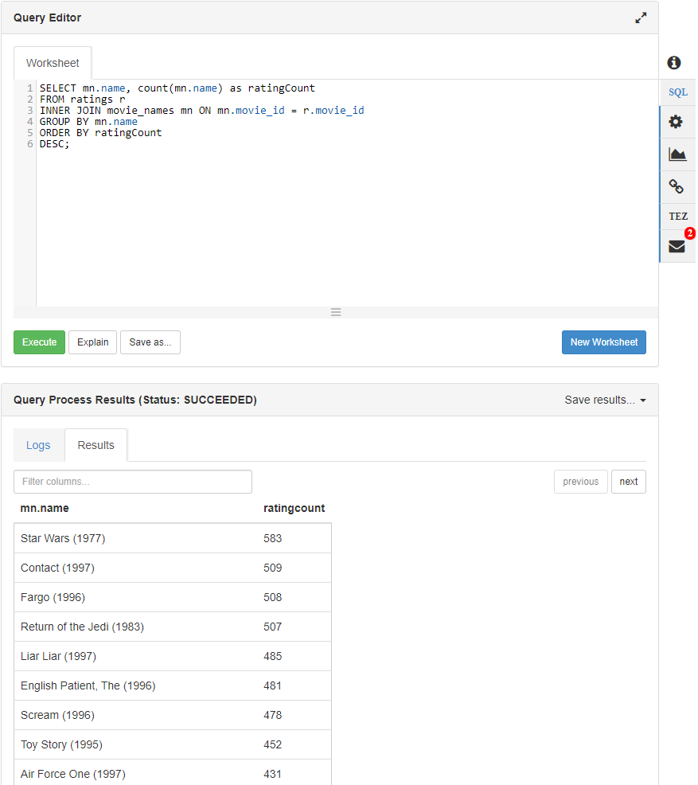

**Step 9:** PuTTY is installed to do the assignment also with Python, MrJob and Nano. 127.0.0.1:2222 with maria_dev is used to login with PuTTY.

**Step 10:** With only PuTTY and the currently running Hortonworks it does not work. A new Hortonworks needs to be installed provided by the teacher. This already includes Python, MrJob and Nano can be used to edit the MrJob code.

**Step 11:** The new Hortonbox is imported to the VM and can be started on the same url as the previous Hortonbox.

**Step 12:** Because this is one is new the dataset has to be inported again.

**Step 13:** Then PuTTY can be starded and logged in.

**Step 14:** Now python HD_rating.py u.data is typed in to check the output. The data still needs to be counted by the ratings given for each movie and sorted by their number of ratings.

**Step 15:** To do so su root is typed in to have the rights to add some code to a copy of the above file with Nano.

**Step 16:** The following code is added to the MrJob code that was already there:

Old:

New:

So the the new code now counts the ratings and returns the movies wich have the heighest count of ratings first.

**Step 17:** Last step is to check if the code works. Herefore the following commands are used.



Old:

New:

Old:

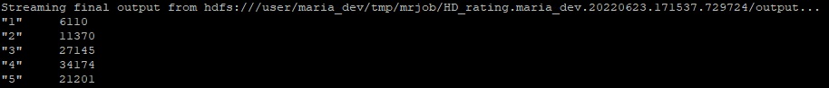

New:

